**WITH NOISE AND WITHOUT FILTER FUZZY**

**Image set:**

|  |
| --- |
| **Image 1:-0.1 % Noise** |

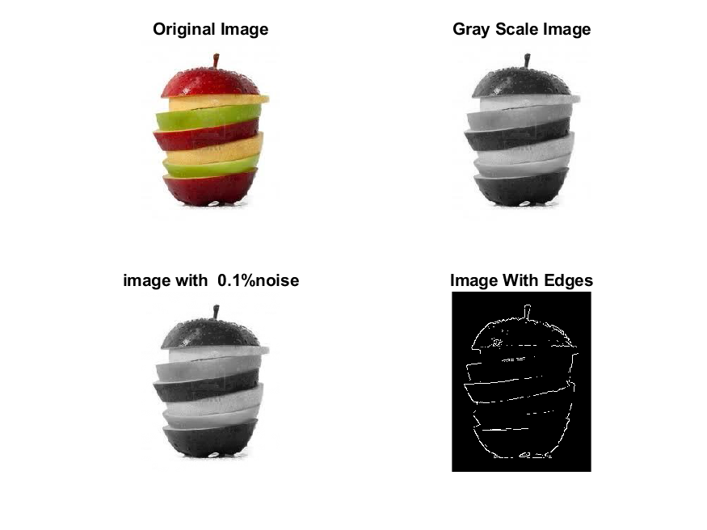

**Image 2:-10 % Noise**

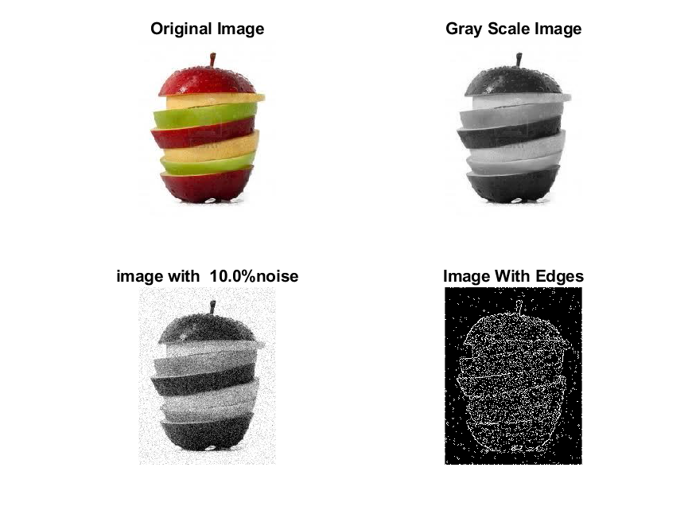

**Image 3:-20 % Noise**

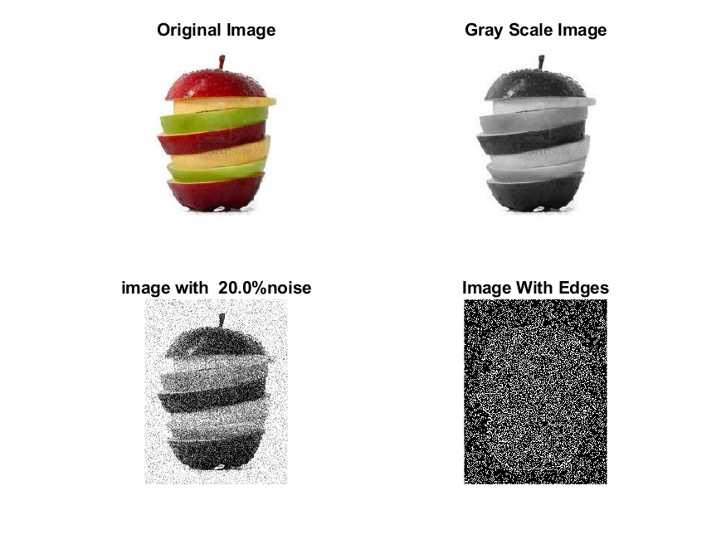

**Image 4:-30 % Noise**

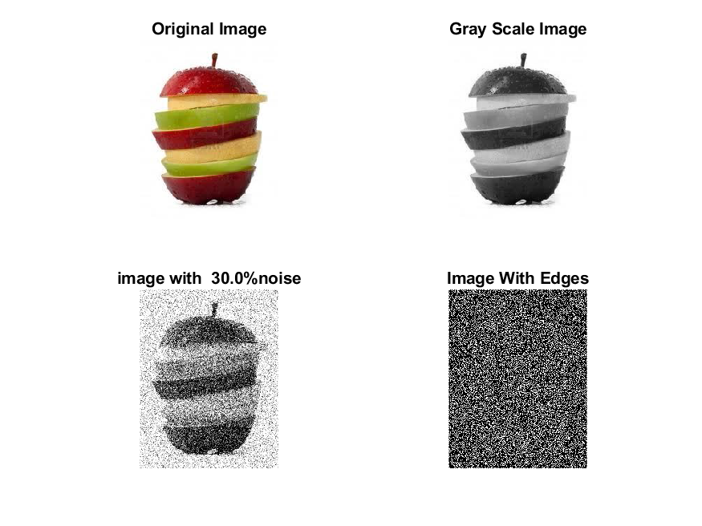

|  |
| --- |
| **Image 5:-40 % Noise** |

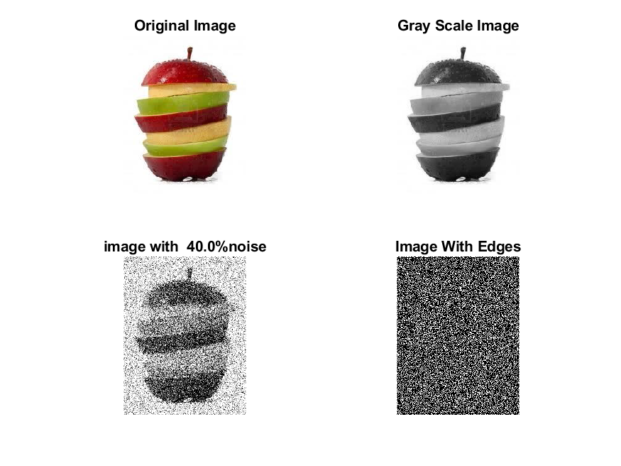

**Image 6:-50 % Noise**

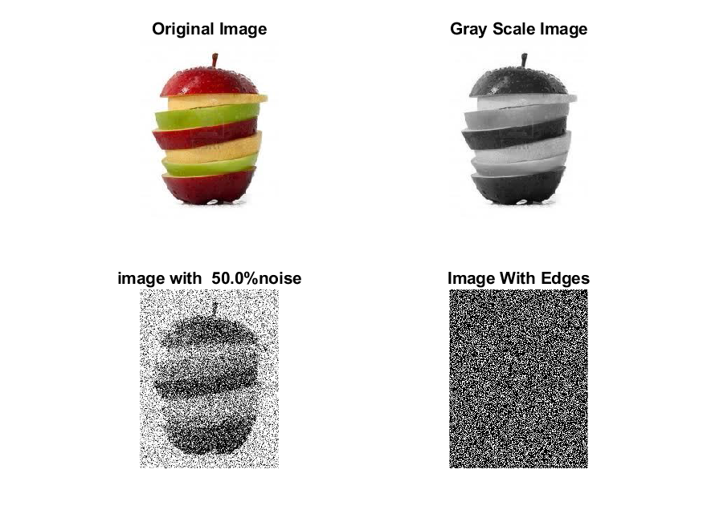

**Image 7:-60 % Noise**

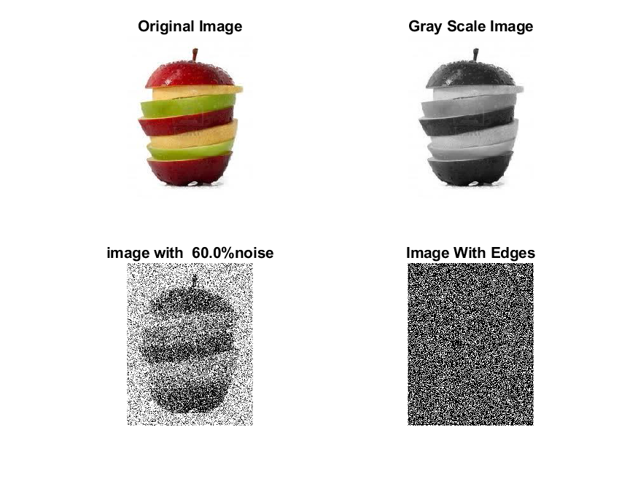

**Image 8:-70 % Noise**

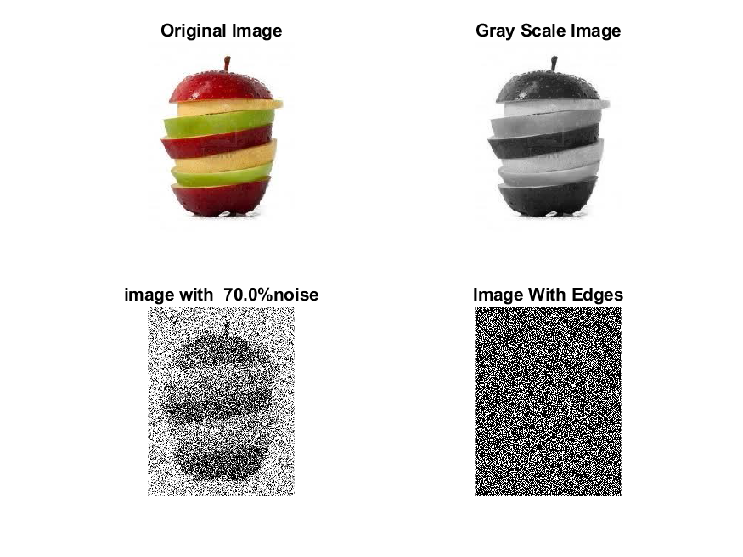

**Image 9:-80 % Noise**

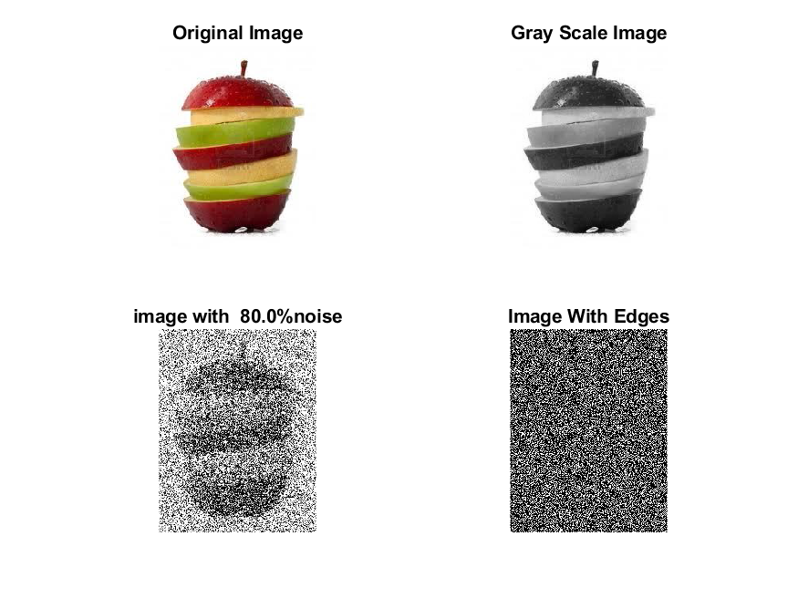

**DATA FILES**

**Image 1:-Noise0.1**

Original image ideal values:

IM1 image entropy:1.817502e-01

IM1 image mean:0.027511

Ground truth image entropy:0.596365

Ground truth image mean:0.144680

entropy between imt and im1 :0.569031

MSE between imt and im1 :0.151369

Average Difference between imt and im1 :0.117169

Maximum Difference between imt and im1 :1.000000

True Positive values:523.000000

False Positive values: 859.000000

True Negative values:42108.000000

False Negative values:6745.000000

Accuracy value: 0.848631

F Measure values:0.120925

Peak Signal-to Noise Ration value: 8.199643

Signal-to Noise Ration value: -7.209069

percentage of pixels that were correctly detected (Pco): 0.071959

The percentage of pixels that were not detected (Pnd):0.928041

the percentage of false alarm: (Pfa):0.118189

Euclidean Distance Value :6.346744

**Image 2:-Noise10**

Original image ideal values:

IM1 image entropy:5.219804e-01

IM1 image mean:0.117448

Ground truth image entropy:0.596365

Ground truth image mean:0.144680

entropy between imt and im1 :0.513876

MSE between imt and im1 :0.202130

Average Difference between imt and im1 :0.027232

Maximum Difference between imt and im1 :1.000000

True Positive values:1507.000000

False Positive values: 4393.000000

True Negative values:38574.000000

False Negative values:5761.000000

Accuracy value: 0.797870

F Measure values:0.228888

Peak Signal-to Noise Ration value: 6.943692

Signal-to Noise Ration value: -0.905629

percentage of pixels that were correctly detected (Pco): 0.207347

The percentage of pixels that were not detected (Pnd):0.792653

the percentage of false alarm: (Pfa):0.604430

Euclidean Distance Value :19.788260

**Image 3:-Noise20**

Original image ideal values:

IM1 image entropy:8.411946e-01

IM1 image mean:0.269812

Ground truth image entropy:0.596365

Ground truth image mean:0.144680

entropy between imt and im1 :0.463895

MSE between imt and im1 :0.321927

Average Difference between imt and im1 :-0.125132

Maximum Difference between imt and im1 :1.000000

True Positive values:2325.000000

False Positive values: 11229.000000

True Negative values:31738.000000

False Negative values:4943.000000

Accuracy value: 0.678073

F Measure values:0.223321

Peak Signal-to Noise Ration value: 4.922427

Signal-to Noise Ration value: 2.706526

percentage of pixels that were correctly detected (Pco): 0.171536

The percentage of pixels that were not detected (Pnd):0.364689

the percentage of false alarm: (Pfa):0.828464

Euclidean Distance Value :16.206834

**Image 4:-Noise30**

Original image ideal values:

IM1 image entropy:8.967516e-01

IM1 image mean:0.313128

Ground truth image entropy:0.596365

Ground truth image mean:0.144680

entropy between imt and im1 :0.460323

MSE between imt and im1 :0.363014

Average Difference between imt and im1 :-0.168448

Maximum Difference between imt and im1 :1.000000

True Positive values:2381.000000

False Positive values: 13349.000000

True Negative values:29618.000000

False Negative values:4887.000000

Accuracy value: 0.636986

F Measure values:0.207061

Peak Signal-to Noise Ration value: 4.400768

Signal-to Noise Ration value: 3.353138

percentage of pixels that were correctly detected (Pco): 0.151367

The percentage of pixels that were not detected (Pnd):0.310680

the percentage of false alarm: (Pfa):0.848633

Euclidean Distance Value :14.196692

**Image 5:-Noise40**

Original image ideal values:

IM1 image entropy:9.155647e-01

IM1 image mean:0.330626

Ground truth image entropy:0.596365

Ground truth image mean:0.144680

entropy between imt and im1 :0.455248

MSE between imt and im1 :0.377366

Average Difference between imt and im1 :-0.185946

Maximum Difference between imt and im1 :1.000000

True Positive values:2460.000000

False Positive values: 14149.000000

True Negative values:28818.000000

False Negative values:4808.000000

Accuracy value: 0.622634

F Measure values:0.206056

Peak Signal-to Noise Ration value: 4.232368

Signal-to Noise Ration value: 3.589286

percentage of pixels that were correctly detected (Pco): 0.148112

The percentage of pixels that were not detected (Pnd):0.289482

the percentage of false alarm: (Pfa):0.851888

Euclidean Distance Value :13.872166

**Image 6:-Noise50**

Original image ideal values:

IM1 image entropy:9.211357e-01

IM1 image mean:0.336200

Ground truth image entropy:0.596365

Ground truth image mean:0.144680

entropy between imt and im1 :0.455441

MSE between imt and im1 :0.383060

Average Difference between imt and im1 :-0.191520

Maximum Difference between imt and im1 :1.000000

True Positive values:2457.000000

False Positive values: 14432.000000

True Negative values:28535.000000

False Negative values:4811.000000

Accuracy value: 0.616940

F Measure values:0.203419

Peak Signal-to Noise Ration value: 4.167336

Signal-to Noise Ration value: 3.661890

percentage of pixels that were correctly detected (Pco): 0.145479

The percentage of pixels that were not detected (Pnd):0.284860

the percentage of false alarm: (Pfa):0.854521

Euclidean Distance Value :13.610065

**Image 7:-Noise60**

Original image ideal values:

IM1 image entropy:9.225744e-01

IM1 image mean:0.337673

Ground truth image entropy:0.596365

Ground truth image mean:0.144680

entropy between imt and im1 :0.457308

MSE between imt and im1 :0.385687

Average Difference between imt and im1 :-0.192993

Maximum Difference between imt and im1 :1.000000

True Positive values:2428.000000

False Positive values: 14535.000000

True Negative values:28432.000000

False Negative values:4840.000000

Accuracy value: 0.614313

F Measure values:0.200404

Peak Signal-to Noise Ration value: 4.137647

Signal-to Noise Ration value: 3.680877

percentage of pixels that were correctly detected (Pco): 0.143135

The percentage of pixels that were not detected (Pnd):0.285327

the percentage of false alarm: (Pfa):0.856865

Euclidean Distance Value :13.376921

**Image 8:-Noise70**

Original image ideal values:

IM1 image entropy:9.260912e-01

IM1 image mean:0.341336

Ground truth image entropy:0.596365

Ground truth image mean:0.144680

entropy between imt and im1 :0.450262

MSE between imt and im1 :0.385010

Average Difference between imt and im1 :-0.196656

Maximum Difference between imt and im1 :1.000000

True Positive values:2537.000000

False Positive values: 14610.000000

True Negative values:28357.000000

False Negative values:4731.000000

Accuracy value: 0.614990

F Measure values:0.207823

Peak Signal-to Noise Ration value: 4.145275

Signal-to Noise Ration value: 3.727732

percentage of pixels that were correctly detected (Pco): 0.147956

The percentage of pixels that were not detected (Pnd):0.275908

the percentage of false alarm: (Pfa):0.852044

Euclidean Distance Value :13.856144

**Image 9:-Noise80**

Original image ideal values:

IM1 image entropy:9.284868e-01

IM1 image mean:0.343884

Ground truth image entropy:0.596365

Ground truth image mean:0.144680

entropy between imt and im1 :0.451690

MSE between imt and im1 :0.388434

Average Difference between imt and im1 :-0.199204

Maximum Difference between imt and im1 :1.000000

True Positive values:2515.000000

False Positive values: 14760.000000

True Negative values:28207.000000

False Negative values:4753.000000

Accuracy value: 0.611566

F Measure values:0.204946

Peak Signal-to Noise Ration value: 4.106824

Signal-to Noise Ration value: 3.760031

percentage of pixels that were correctly detected (Pco): 0.145586

The percentage of pixels that were not detected (Pnd):0.275137

the percentage of false alarm: (Pfa):0.854414

Euclidean Distance Value :13.619244